Project 2

Movie Lens - Business Report

Movie Lens is a company in the internet and entertainment domain providing an online database of information related to films, television series, and online streaming content including cast, production crew, trivia, ratings, fan, and critical reviews. Every year in collaboration with a guest curator, Movie Lens publish their annual insights based on a theme providing a comprehensive view of a topic. The company is planning to bring out the "Movie Talkies: Classic" edition this year. The idea is to connect with viewers who have strong movie preferences as well as promote classic movies to attract newer customers and expand their viewer base.

Q1. How many movies were released until 2000? How many distinct genres have come up till the year 2000?

A1. 3883 movies 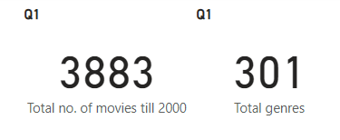were released until 3883 with 301 different genres.

Q2. How many users are part of the Movie Lens community, and what is the gender diversity in this community?

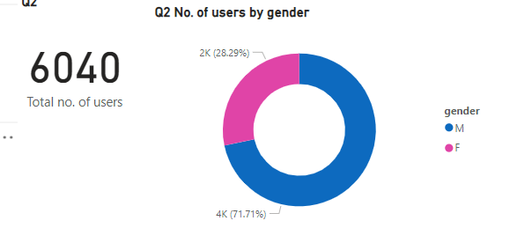A2. As per the data 6040 users are part of the Movie Lens community. Among wich 4331 are male users and 1709 are female users.

Q3. What are the genre preferences of different genders, highlighting user engagement?

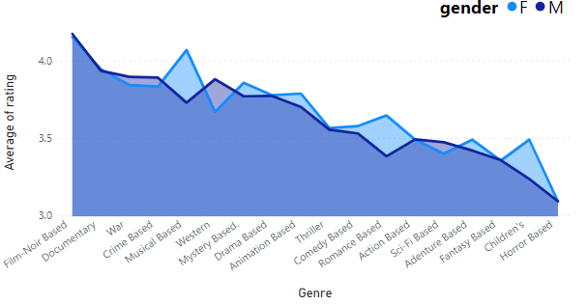A3.

Film-Noir-based movies appear to be preferred by both genders, while horror movies are observed to be enjoyed the least by both. Additionally, females seem to prefer musical-based movies more than males do."

Q4. What's the average user rating for classic movies, reflecting overall reception? How does the distribution of movies vary across different genres?

A4. Average user rating for classic movies is 3.58. Avg. rating given by female users is 3.62 whereas the same given by males is 3.57.

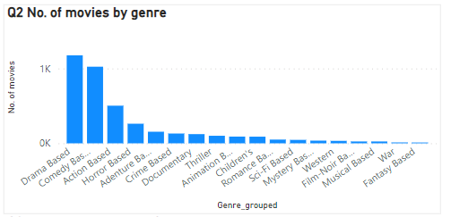Most number of movies released are in the Drama segment while fantasy based movies are the least.

###### Q5. How does the demographic distribution of the users look like across gender? Where do these users live?

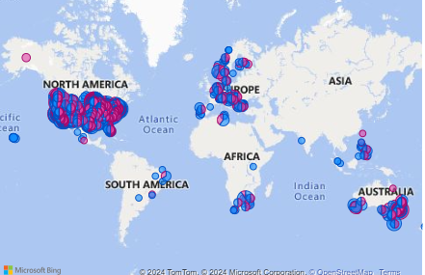A5. Most of the users are from USA.

###### Q6. How do users across different age groups and professions engage with classic movies, revealing generational interests?

###### A6.

Above table can be observed to see the movies rated by people from different age groups and from different professions.

Moreover these can also be observed for different genres by applying filter from the Power BI dashboard.

Q7. Which classic movies and genres are top-rated? How do these ratings differ based on user age and occupation?

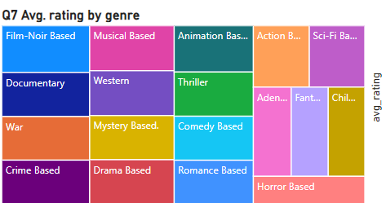A7. Film-Noir genre movies are best rated whereas the horror movies are least rated.

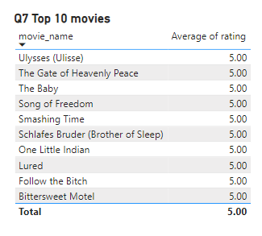Also top 10 highest rated movies are :

Q8. Is there a link between user age and the ratings they provide for classic movies, providing insights into age-related viewing habits? How do the average ratings vary over the years based on the genre considered?

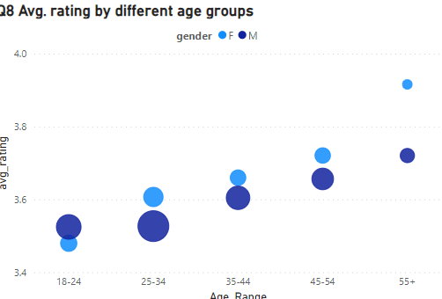A8.

Older users seem to be rating movies higher than younger users.

Average ratings through the decades are as follows:

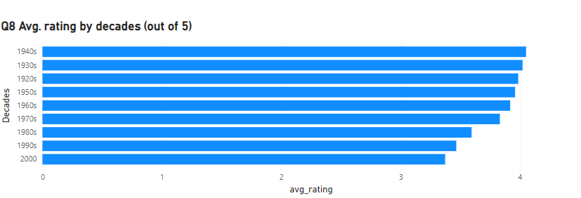

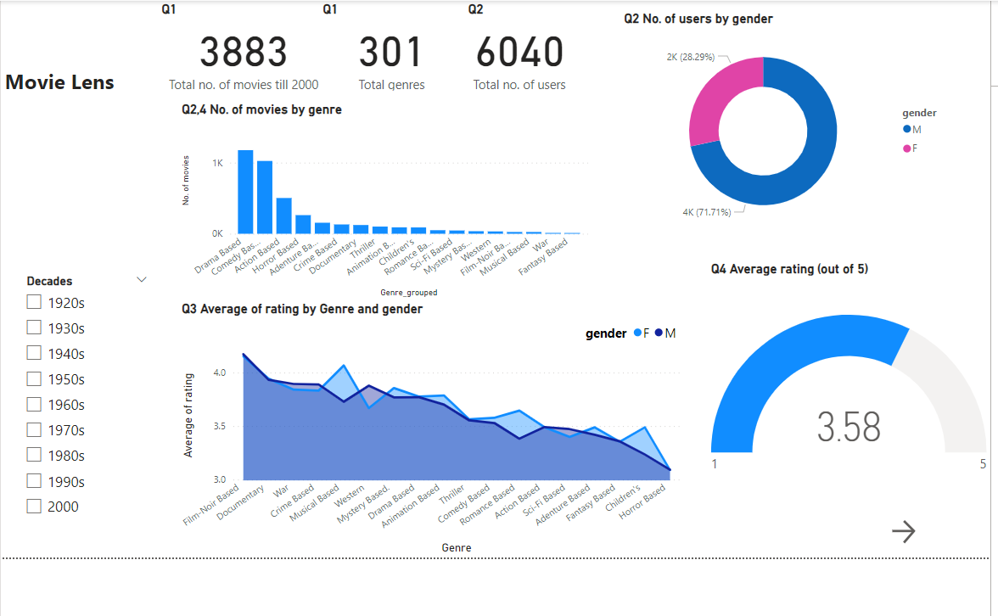Screenshots from Power BI:

